**Example – 1**  
**Rank Function:**

To Rank based on a measure used in the Visual.

Old Way:

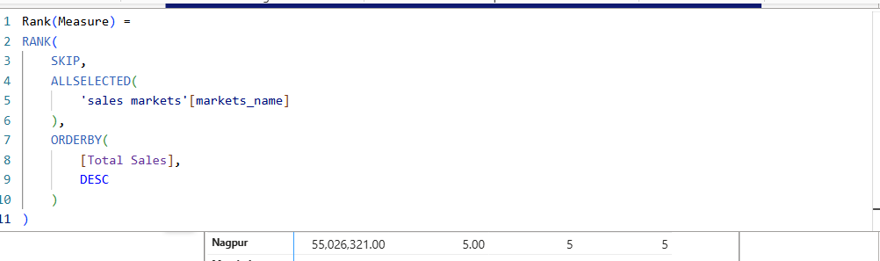

**Or**

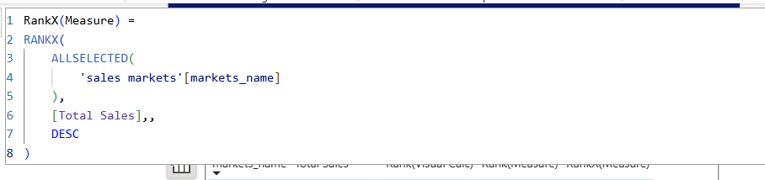  
Visual Calculation: The visual calculation version of RANK is easier to work with because it doesn’t require using functions like ALLSELECTED() or ALL(), which can feel a bit intimidating for someone who isn’t very comfortable with DAX yet.  
  
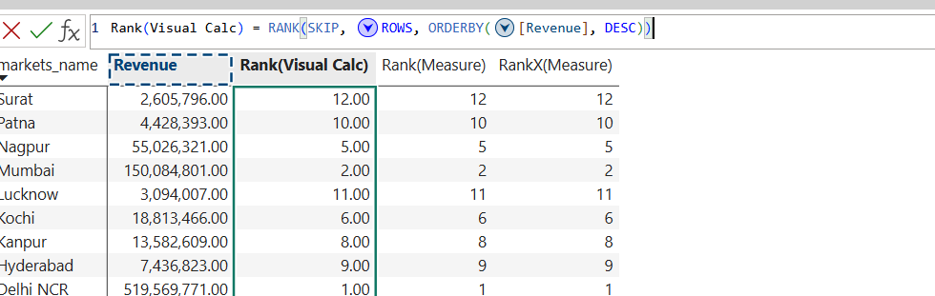

**Example – 2**

**LookUP Value & LookUP Total Value functions:**

**LookUP Value:** To retrieves a single value from a column in a table that matches one or more search conditions.

Old Way:

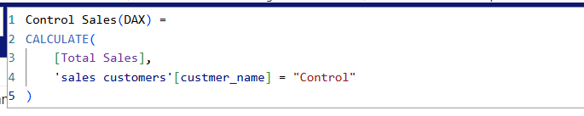  
Visual Calculation: This way, Microsoft has given us a built-in function where you just fill in the parameters, so even someone with limited Power BI or DAX experience can use it easily.

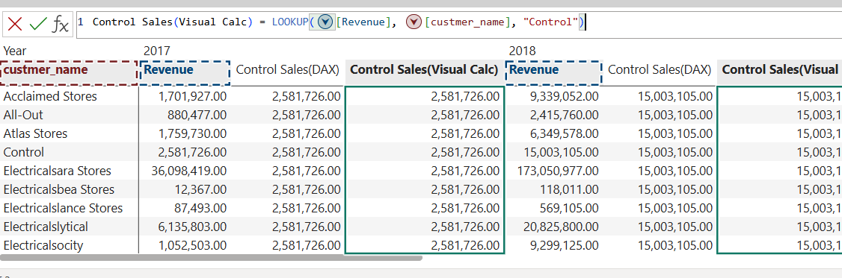

**LookUPWithTotals:** This function evaluate expression in visual matrix with totals.

Old Way:

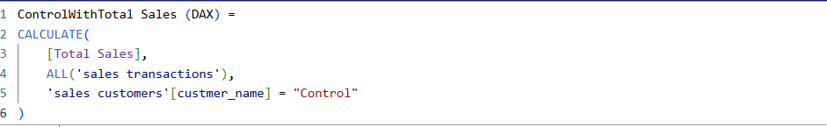  
Visual Calculation: With a DAX calculation, we’d need to use two filters inside a CALCULATE function and also include an ALL() function. But with a visual calculation, we can achieve the same result much more easily using the built-in LOOKUPWITHTOTALS() function.

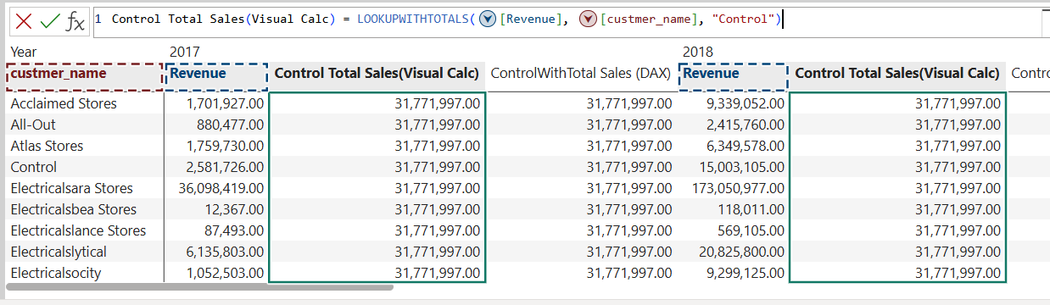

**Example – 3**

**Percent of parent (Collapse):**

It's a way to see what percentage each item contributes to its larger group.

**Collapse():** In this,calculation is evaluated at a higher level of the axis.

Old Way:

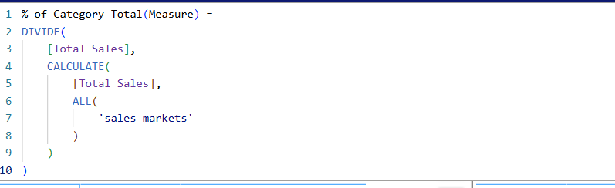

Visual Calculation: This way, we can skip the complicated ALL() function and make the calculation automatically aware of the right totals by using the Collapse() function.